**BANGABANDHU SHEIKH MUJIBUR RAHMAN SCIENCE AND TECHNOLOGY UNIVERSITY**



**Project Report On HOME-FTP**

**Course Code: CSE278**

**Course Title: Project**

|  |  |
| --- | --- |
| **Submitted By** | **Submitted To** |
| **Yeasin Arafat- 18ICTCSE003**  **Roksana Akter -18ICTCSE004**  **Year:** 2nd  **Semester:** 2nd  Department of CSE, BSMRSTU | **Dr. Saleh Ahmed**  **Associate Professor**  Department of CSE, BSMRSTU |

## Contents

Letter of Approval 3

Introduction: 4

Objectives: 4

Technologies Used: 4

System Architecture: 4

Server: 4

Clients: 4

Implementation Details: 5

Server-side: 5

Client-side: 5

Features: 5

File Share: 5

File Receive: 5

Host Management: 5

Settings: 5

Use Case Diagram: 6

User Interface of Home FTP: 6

Home Page: 6

File Sharing Page: 7

Host Management Page: 8

Server Page: 8

Conclusion: 9

References: 9

# Letter of Approval

**To:**

**Name:** Yeasin Arafat

**Student ID:** 18ICTCSE003

**Name:** Roksana Akter

**Student ID:** 18ICTCSE004

Department of CSE, BSMRSTU

**Subject: Approval for the "Home FTP" Project**

I am pleased to approve your project titled "**Home FTP**," which focuses on developing a LAN-based file sharing application using Java Socket Programming. Your project proposal demonstrates the potential to create a useful and practical solution for file sharing within our local area network.

I encourage you to proceed with the development and implementation of the project, and I look forward to seeing the positive outcomes of your efforts. Should you require any assistance during the process, please do not hesitate to reach out.

Best wishes for the success of the "**Home FTP**" project.

Sincerely,

Dr. Saleh Ahmed

Associate Professor

Department Of CSE, BSMRSTU

# Introduction:

The purpose of **“Home FTP”** project is to develop a LAN-based file sharing application using Java Socket Programming. The application enables users on the same local area network (LAN) to share files seamlessly and securely. The project utilizes the client-server architecture to facilitate the transfer of files between multiple clients connected to a central server.

# Objectives:

* Enable file sharing between clients connected to the same LAN.
* Implement a secure and reliable file transfer mechanism.
* Provide a user-friendly interface for selecting and transferring files.
* Support concurrent connections from multiple clients.
* Implement basic error handling and data validation.
* Ensure efficient data transfer and minimize latency.

# Technologies Used:

* Java: Programming language for application development.
* Socket Programming: API for network communication.
* Java Swing: Library for building the graphical user interface.

# System Architecture:

The system architecture consists of two main components: the server and the clients.

## Server:

* Accepts incoming connections from multiple clients.
* Manages the file sharing requests and transfers.
* Handles authentication and authorization of clients.
* Facilitates the transfer of files between clients.

## Clients:

* Connect to the server to initiate file sharing.
* Authenticate with the server using a username and password.
* Browse and select files for sharing.
* Upload files to the server or download files from other clients.

# Implementation Details:

## Server-side:

* Set up a server socket to listen for incoming connections.
* Maintain a list of connected clients and handle concurrent connections.
* Authenticate clients using username and password verification.
* Implement file transfer functionality using input/output streams.
* Implement multi-threading to handle multiple file transfer requests.

## Client-side:

* Establish a socket connection with the server.
* Implement user authentication using a login screen.
* Display the list of connected clients and available files.
* Allow clients to browse, select, and upload/download files.
* Show the progress of file transfers and handle any errors.

# Features:

## File Share:

* Public Share: Allows users to share files publicly with all connected clients on the LAN.
* Private Share (Peer-to-Peer): Enables users to share files directly with specific clients on the LAN.

## File Receive:

* Download from FTP: Provides the capability to download files from an FTP server.
* User Management: Allows the system administrator to manage user accounts, including data providers and registered users.

## Host Management:

* Add New Host: Allows the system administrator to add new hosts or devices to the LAN.
* Delete Existing Host: Provides the ability to remove existing hosts or devices from the LAN.

## Settings:

* Profile Name Modification: Allows users to modify their profile names or usernames.
* File Path Modification: Enables users to modify the default file path for file storage or sharing.

# Use Case Diagram:

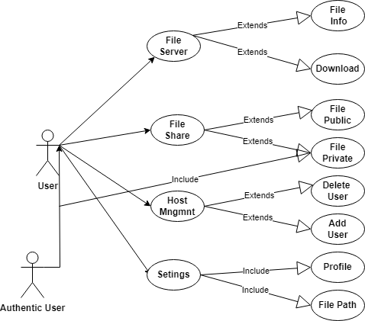

Figure 1:Use Case Diagram OF Home FTP

# User Interface of Home FTP:

## Home Page:

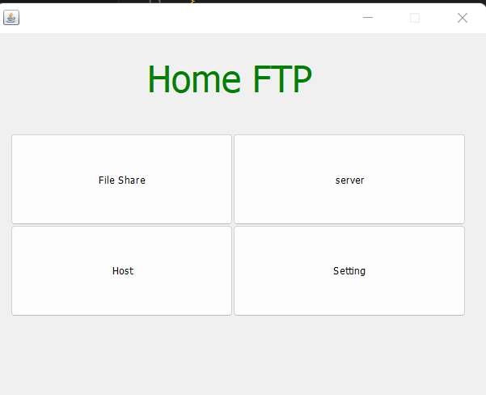

Figure 2:"Home FTP" Home Page

## File Sharing Page:

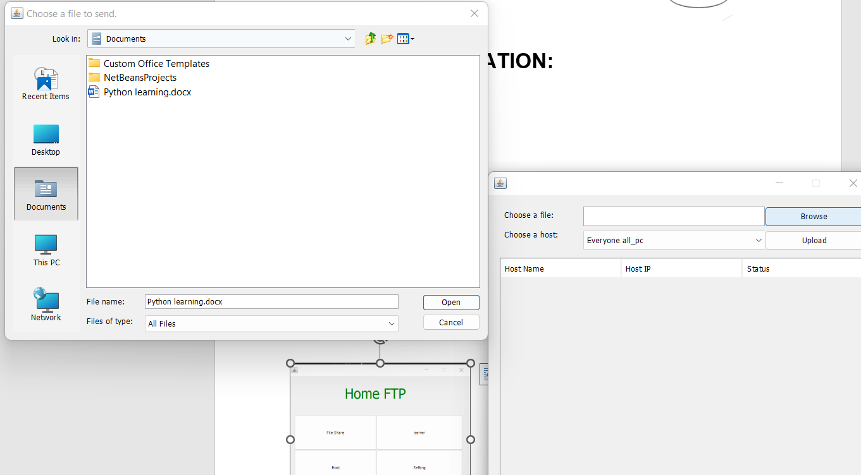

Figure 3:File sharing Page Of File Selected

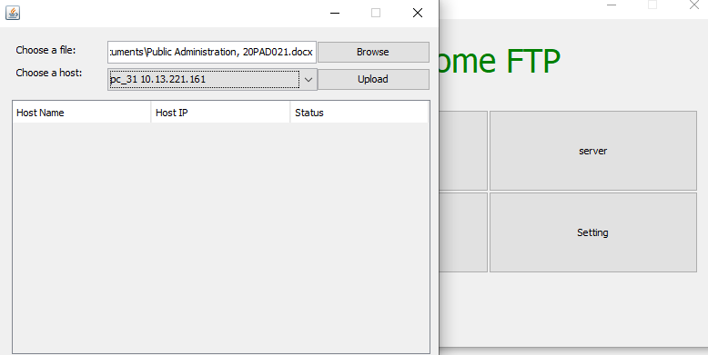

Figure 4:File Sharing Page

## Host Management Page:

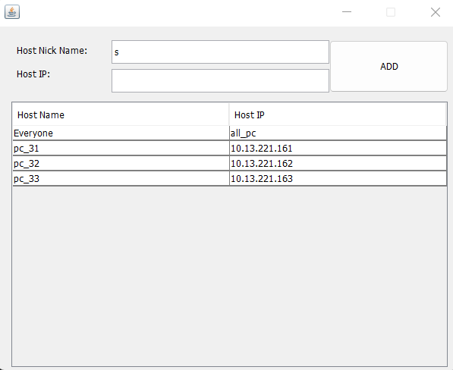

Figure 5:Host Management Page

## Server Page:

Figure 6:Server Page

# Conclusion:

The LAN-based file sharing application developed using Java Socket Programming provides a reliable and secure platform for sharing files within a local area network. The client-server architecture allows for concurrent connections and efficient file transfers. The application offers a user-friendly interface, ensuring a seamless experience for users. Future enhancements could include additional security features, such as encryption, and the implementation of a more robust error handling mechanism.

# References:

Oracle Java Documentation: <https://docs.oracle.com/en/java/>

Java Socket Programming Tutorial: <https://www.javatpoint.com/socket-programming>